Ubuntu 22.04/20.04 update installed packages for security
The procedure to install updates and security patches on Ubuntu:
- Open the terminal application.
- For remote server log in using the ssh command:
ssh username@your-ubuntu-server-ip.
$sudo -i for sudo privilege

- Run the command sudo apt update to refresh package database.
Step 1
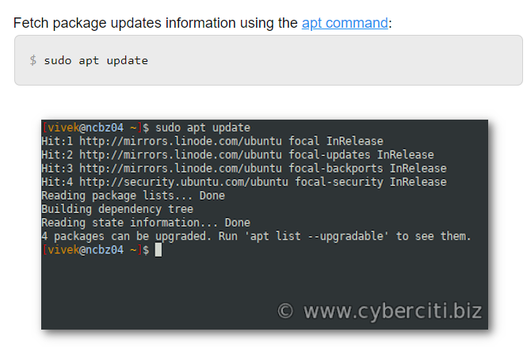

Step 2 – Find out information about available Ubuntu security-related updates
It is a good idea to list out all updates available for the box. Hence, we run the following command:
Show information about available update/packages/pathces, run:
sudo apt list –upgradable

$ sudo apt list --upgradable
outputs:
Listing... Done
distro-info-data/focal-updates,focal-updates 0.43ubuntu1.1 all [upgradable from: 0.43ubuntu1]
libnetplan0/focal-updates 0.99-0ubuntu2 amd64 [upgradable from: 0.99-0ubuntu1]
netplan.io/focal-updates 0.99-0ubuntu2 amd64 [upgradable from: 0.99-0ubuntu1]
python3-requests/focal,focal 2.22.0-2ubuntu1 all [upgradable from: 2.22.0-2build1]

Step 3 – Install updates via apt command line for Ubuntu 22.04

Apply security updates and patches for all installed apps, run:

Fire up a terminal application or log in using ssh command. Run the apt command to upgrade all installed packages on Ubuntu Linux system:
$ sudo apt upgrade

When promoted as follows, type “Y” and press the [Enter] key to confirm operation of patching and applying updates on Ubuntu:
Do you want to continue? [Y/n]

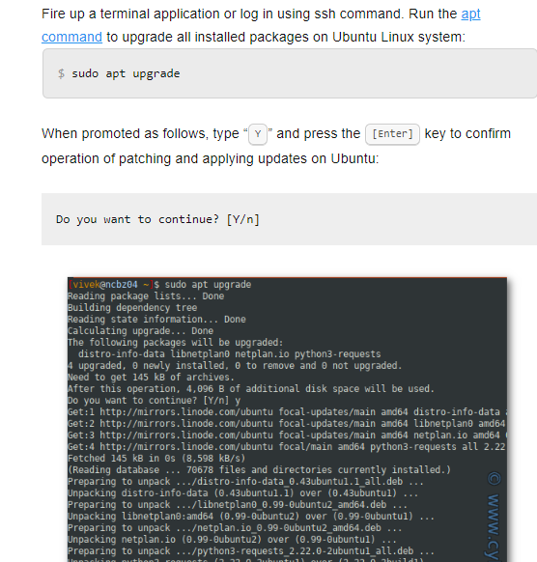

- Reboot the system if kernel was updated by typing sudo reboot command.
===============================================================================
For security patching checking and installing in ubuntu server
==================================================
- root@Linux-Test:~# apt update
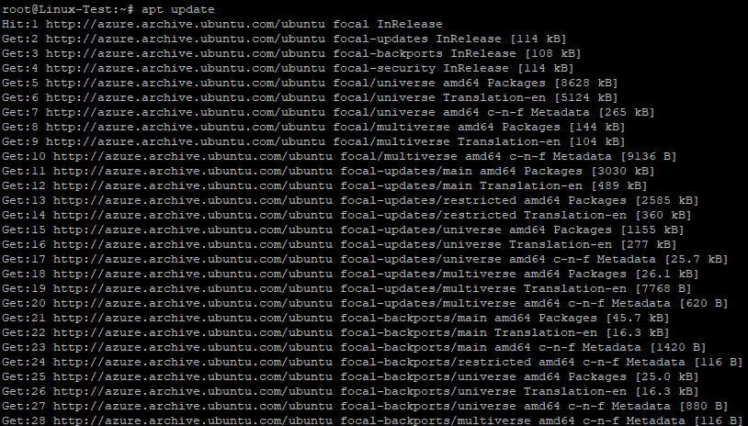
- root@Linux-Test:~# apt list –upgradable
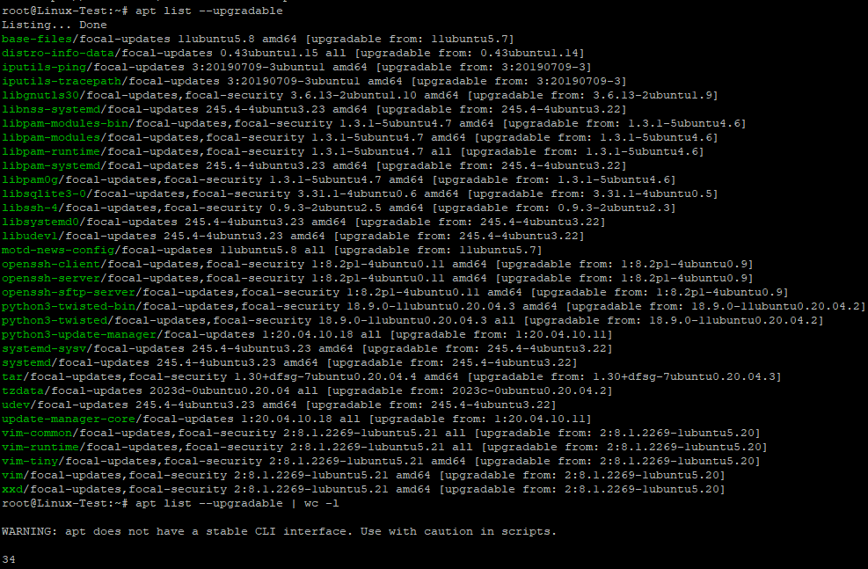
- root@Linux-Test:~# apt list --upgradable 2>/dev/null | grep "\-security"
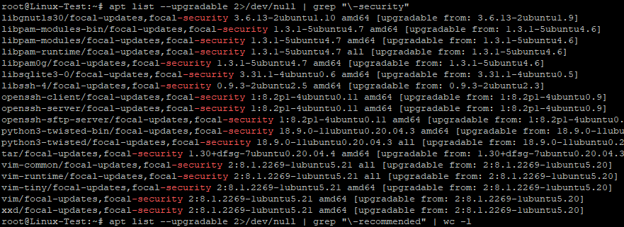

- root@Linux-Test:~# apt list --upgradable 2>/dev/null | grep "\-security" | wc -l
18

- root@Linux-Test:~# apt-get -s dist-upgrade | grep "^Inst" | grep -i securi | awk -F " " {'print $2'} | xargs apt-get install

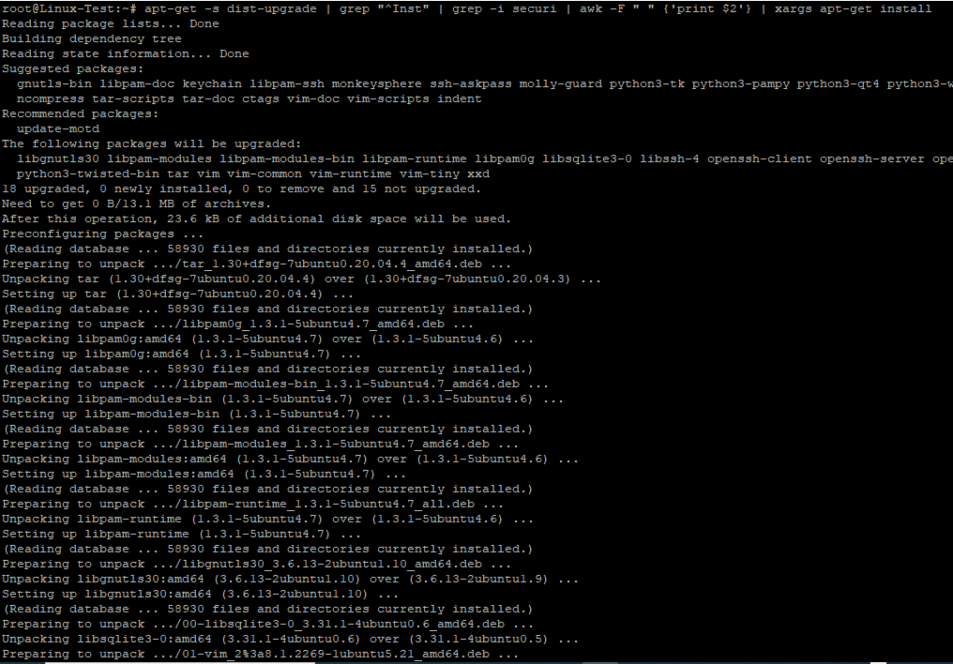
- root@Linux-Test:~# apt list --upgradable 2>/dev/null | grep "\-security" | wc -l
0
root@Linux-Test:~# apt list --upgradable 2>/dev/null | grep "\-security"
root@Linux-Test:~#
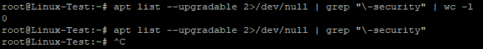

- Reboot the system if kernel was updated by typing sudo reboot command.

